13.58: Denote the mass of the passengers by m and the (unknown) mass of the car by M. The spring cosntant is then 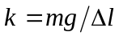. The period of oscillation of the empty car is 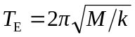 and the period of the loaded car is
